**INVERSE MIXCOLUMNS - TB**

Módulo Inverse Mixcolumns recebeis_row(do módulo ShiftRows), processa e entrega *im_col*. É isso que será verificado no teste (dados do FIPS 197)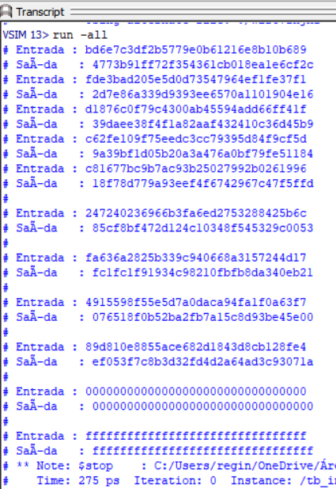

round[ 1].is_row bd6e7c3df2b5779e0b61216e8b10b689

round[ 1].im_col 4773b91ff72f354361cb018ea1e6cf2c

round[ 2].is_row fde3bad205e5d0d73547964ef1fe37f1

round[ 2].im_col 2d7e86a339d9393ee6570a1101904e16

round[ 3].is_row d1876c0f79c4300ab45594add66ff41f

round[ 3].im_col 39daee38f4f1a82aaf432410c36d45b9

round[ 4].is_row c62fe109f75eedc3cc79395d84f9cf5d

round[ 4].im_col 9a39bf1d05b20a3a476a0bf79fe51184

round[ 5].is_row c81677bc9b7ac93b25027992b0261996

round[ 5].im_col 18f78d779a93eef4f6742967c47f5ffd

round[ 6].is_row 247240236966b3fa6ed2753288425b6c

round[ 6].im_col 85cf8bf472d124c10348f545329c0053

round[ 7].is_row fa636a2825b339c940668a3157244d17

round[ 7].im_col fc1fc1f91934c98210fbfb8da340eb21

round[ 8].is_row 4915598f55e5d7a0daca94fa1f0a63f7

round[ 8].im_col 076518f0b52ba2fb7a15c8d93be45e00

round[ 9].is_row 89d810e8855ace682d1843d8cb128fe4

round[ 9].im_col ef053f7c8b3d32fd4d2a64ad3c93071a

teste 0 128’h0

teste 1 128’h1



